1. 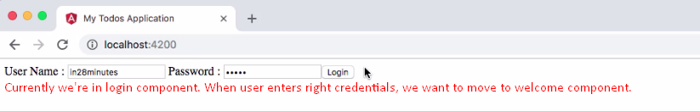
2. That is where routing comes into picture. Let’s look at the basics of routing.